STONEBRIDGE ANNUAL HOMEOWNERS ASSOCIATION MEETING
August 4, 2022 – 7 pm
Lunar Bowl

Present: Phil Leslie (President), Hugh Rathbun (Treasurer), Viv Glenn-Hough (Secretary), Jorge Gonzalez (Architectural Committee Chair), Gary Hough, Rachel Lopez, Dave & Patty Parkin
Absent and excused: Jon Mitchell, Windy Stewart, Marc Edwards

Finances: the following amounts were in our bank accounts as of these dates:
- Checking $1090.59 (8-4-22)
- Savings $643.66 (8-4-22)
- Country Club Bank (for HA-KC use) $17,669.10 (6-30-22)
- Certificate of deposit $38,958.10 (6-30-22)

Phil advised we had received payment on 2 accounts that we had filed liens on for past due HOA dues: the Hurlas (approximately $2300) and Wilkerson (approximately $1900).

HOA Complaints: We discussed the property at 209 NE Bridgeport, where we have received complaints from neighbors. This owner has also received complaints from the city of Blue Springs regarding code violations and have cleared up at least one of those items (fence) but there are still some issues that need to be addressed: dead tree removed, repaint house and repair wood rot. Blue Springs Animal Control also has an open investigation regarding potential rabbits at the home.

HOA Architectural Committee Requests:
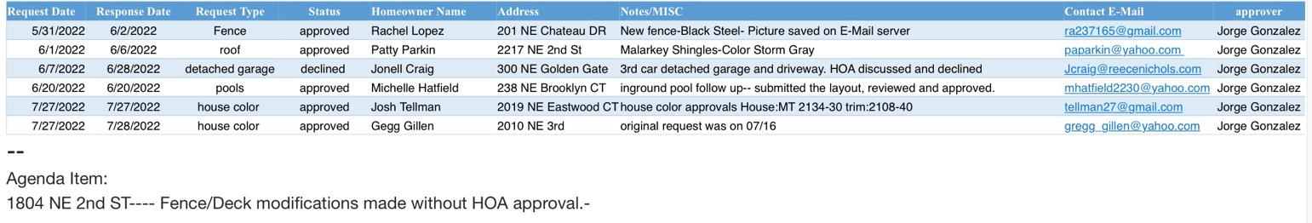
Jorge Gonzales submitted the report below from the HOA Architectural Committee, which are requests we have received for changes to homeowners physical property.
Jorge advised that one request to add a third detached garage was denied, and there was a complaint about the fence poles at another address being too high and in violation of the city of Blue Springs code.

Other Items:

Viv advised that we received a request from Weatherstone HOA regarding next year’s annual neighborhood garage sale. Weatherstone has their annual garage sale the first weekend of June and said they have partnered with several other HOAs on Duncan Road for this weekend annually and thinks it might benefit our neighborhood too. We will look into possibly trying that in 2023.

Phil advised he had recently discussed trash service with Lies to inquire about an HOA discount for Stonebridge but there is nothing confirmed at this time. Motion seconded and passed, however, to see if there is a potential discounted group rate through Lies. Phil will talk with Lies will get exact information and discuss at the next meeting.

Phil advised that the electricity and fountain problem had been repaired at the pond. Everything is working again.

Discussion followed about the Block Party scheduled for August 20 (rain date August 27). It will be held at the NE Stonebridge Ct cul-de-sac, which is where we have held it for the past few years. Phil will get a flyer to HA-KC to send out to our neighborhood to remind everyone.

We discussed the following items and who would be responsible for each one:

Food and drinks (hotdogs and hamburgers): Phil
Grills: Phil, Jon and Jorge and potentially one of Phil’s neighbors
Ice cream man: Phil
Bounce house: Phil advised it has been reserved
Police department: Phil and/or Jon
Fire department: Jon
Duck pond: Rachel
Face painter and balloon artist: Viv has reserved and paid for Fine Tooners
City notification: Jon
Fishing derby: Gary
Door and fishing derby prizes: Phil
Movies: we suggested Willy Wonka and the Chocolate Factory, Matilda and Big Hero. Those were polled on our Facebook page and ultimately Big Hero was selected (Rachel has the DVD).

The next HOA meeting will be held on Thursday, October 6, 2022 at 7 pm at Lunar Bowl in their conference room. All Stonebridge HOA residents and children are welcome! Please come meet your HOA board and neighbors.

Respectfully submitted,

Viv Glenn-Hough, Secretary

